**MILLSTONE EDGES WEEKEND**

Final details for Curbar, Froggatt and Baslow Edges

**Day 1, Saturday 13 Jan 2024**

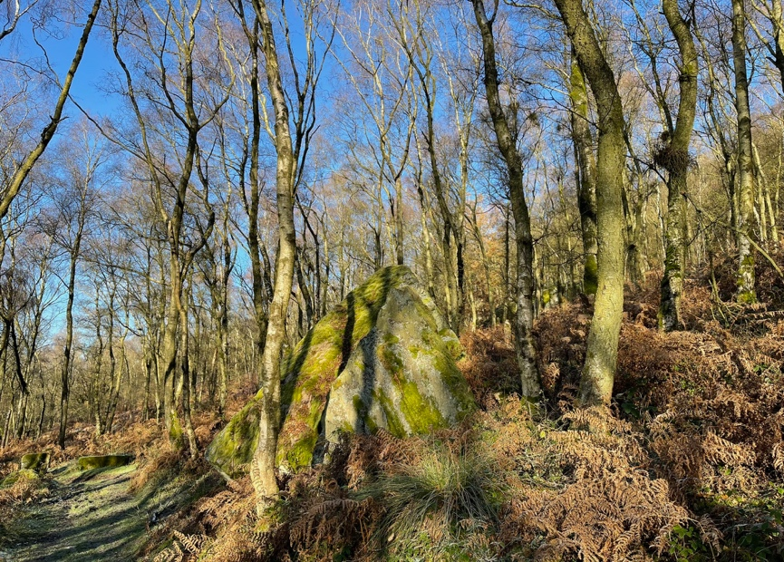

**How to enter**

Entries are open on [Fabian4](https://www.fabian4.co.uk/default.aspx?EventID=2898) with self-select start times from 11.00 -1.00.  No entry on the day.

Until midnight on Sunday 7th January:

BO member - £10 Non-member - £12

Juniors, students (and adults on white, yellow or orange) £6

Family (for people participating on different courses) members - £26, non-members - £30

**Until midday on Friday 12th January (subject to map availability):**

BO member - £11, Non-member - £13

Juniors, students (and adults on white, yellow or orange) £7

Family (for people participating on different courses) members - £29, non-members - £33

Discount for entering both days £1. SI card hire £1

Helpers get a free run.

If you are competing as a pair just enter one person. If you are accompanying a junior - just enter the junior.

**Parking**

Parking is at Cliff College, Cliff Lane, Hope Valley S32 3XG. <https://maps.app.goo.gl/79myZNq7McMGHRZ58>

It will be signed from the A623. Take care turning in and out of the entrance and approach from the north if possible to save turning into oncoming traffic. Please do not approach via the Curbar Gap road, it is essentially single track and heavily used by walkers etc and residents of the village do not appreciate extra traffic. Please park as directed, either on hardstanding or on the reinforced grass. Do not park anywhere else. There is a single entry and exit point, please take care if exiting while others are entering. Parking is limited so share cars if you can. In the event of more cars than Cliff College can accommodate, it may be necessary to redirect you to roadside parking by the church and school in Curbar village, which will entail a 5 minute walk via a footpath to Cliff College. See general parking map.

Please contact the organiser if you plan to bring an unusually large minibus or large camper.

There are Hope Valley bus stops on the A623 at the entrance to Cliff College served by buses 257, 025, 218 and 66 and also buses to Calver which is walking distance to Cliff College. Please refer to relevant timetables for the services.

Accommodation is available at the college on a B+B basis please contact them directly <https://cliffcollege.ac.uk/venue>

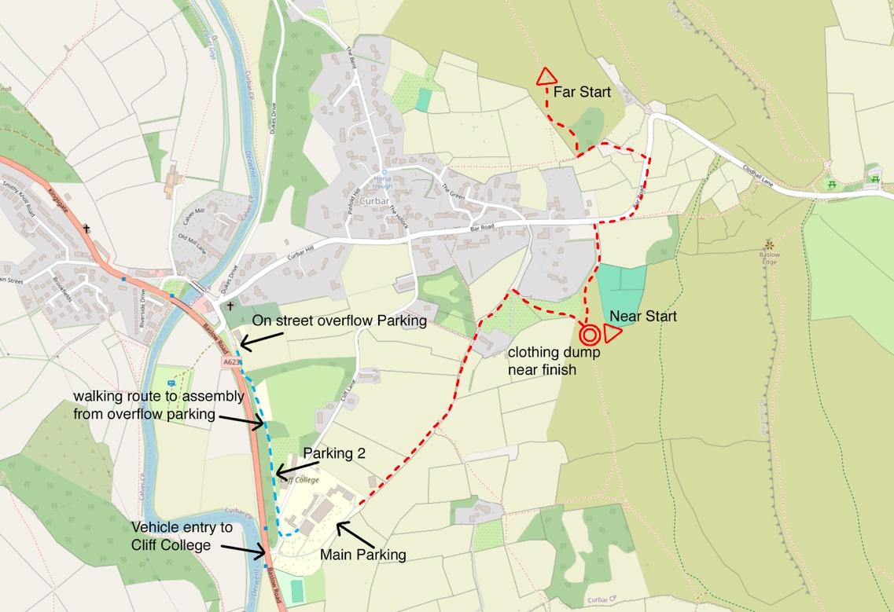

**Assembly**

Please follow signs to assembly. The assembly room will contain enquiries, dibber hire collection and download. (Enquiries open from 10.00).Toilets adjacent and also in an outside building on leaving for the starts, but no toilets at the starts. On returning please ensure muddy shoes are taken off before entering the building.

Tea, coffee and biscuits will be available to buy in the cafeteria. Cash only, into a collection box – no card payments.

**Terrain**

The area comprises a mix of steep wooded slopes with complex rock detail and open areas with a network of walls, many of them ruined. Longer courses will reach the open moorland of the Big Moor plateau above the eponymous edges. There is some dead bracken, courses are planned  to maximize the use of the nicest areas.

# **Walls and Crossing Points**

There are a number of walls that are forbidden to cross. All are marked with a thick purple overprint line. Please only cross these boundaries at marked gaps or crossing points. Future use of the area depends on our cooperation with the landowners.

# **Timed-Out Road Crossing**

There is a two minute timed-out road crossing on all courses from the far start. There will be a taped route between two controls, roughly 100m, which should take no more than one minute at a walking pace, so there is no need to rush to cross the road.

# **Orange Course**

This course follows a path along the top of some high crags. The path is a safe distance from the edge, but unaccompanied juniors should be advised not to stray from their course or approach the edge of these crags.

# **Public**

This is a public area and is well used by climbers, hikers and dog walkers. Please be respectful of the rights of other users of the area.

**Starts**

Please use the toilets at the college before going to the start and do not relieve yourselves on the start route.

There are two starts: near start for competitors on white, yellow and orange; far start for competitors on all other courses. The near start is 1km gently uphill from assembly and is adjacent to the finish. The far start is a further 600m including a short section following and crossing a minor road. Please take care and walk on the right, facing oncoming traffic, until the sign for you to cross.

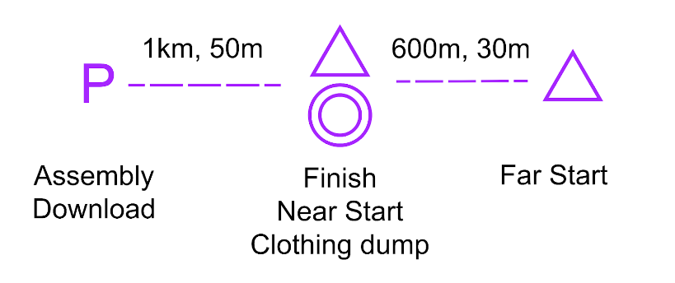

There will be a clothing dump at the finish. All items are left at the competitor’s own risk. Close by, and of historical interest, is an old burial site for victims of the Great Plague. Please be respectful of this.

Start times from 11.00am to 1.00pm. Please try to start in your block but it is a punching start so don't worry if you are late. Courses close 2.30pm promptly. **If you think you might take a long time, please select an early start block.**

Blank maps will be displayed in the start lanes. There will be loose control descriptions available in the start lanes. The controls will be SIAC enabled but you must manually punch the start and finish.

All maps will be at the starts. White and yellow are before the start lanes and may be viewed before starting. Please note: the far start and the finish are situated on reasonably well-used public footpaths, so please be respectful to members of the public who may be passing through.

|  |  |  |  |  |  |
| --- | --- | --- | --- | --- | --- |
| **Course** | **Length** | **Climb** | **Navigational difficulty** | **Start** | **Map scale** |
| Black | 5.0km | 300m | Hard | Far | 1:10,000 |
| Brown | 4.4km | 260m | Hard | Far | 1:10,000 |
| Blue | 4.1km | 225m | Hard | Far | 1:10,000 |
| Green | 3.5km | 180m | Hard | Far | 1:7,500 |
| Short Green | 3.1km | 125m | Hard | Far | 1:7,500 |
| Light Green | 3.1km | 105m | Moderately Hard | Far | 1:7,500 |
| Orange | 2.1km | 95m | Medium | Near | 1:7,500 |
| Yellow | 1.6km | 40m | Easy | Near | 1:7,500 |
| White | 1.3km | 20m | Very Easy | Near | 1:7,500 |

**Finish**

The finish is approximately 1km uphill from assembly and is adjacent to the near start and en-route to the far start. Remember to collect items you may have left at the clothing dump.

**DO NOT FORGET TO DOWNLOAD** **AT ASSEMBLY**

**Courses close at 2.30pm. The nature of the terrain may slow you down, please start early enough to finish by this time.**

# **Map**

1:10000 & 1:7500, 5m contours.

Based on the 2009 Peel Land Surveys map with major updates by Ian Cooper, 2011.   
Conversion to ISOM 2017-2 and updated survey by Ian Cooper and Peter Gorvett (both SYO) 2020/22.   
Minor updates 2023 by Oli Johnson. Map printing by Hassall and Lucking.

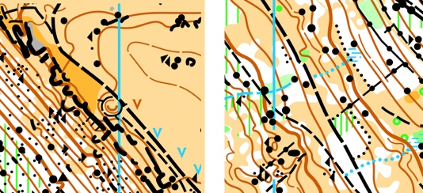

Rock mapping is selective and is generally limited to features that are more than 1m high or otherwise distinctive. Boulders that are large in area but less than a metre high have been mapped using the grey "bare rock" symbol. Rough open is generally deep heather or bracken, which has flattened down nicely. Paths marked as less distinct or small are generally deer trods, only the more prominent are mapped, there are many other smaller seasonal ones particularly in the bracken. The undergrowth screen is generally bramble. Much of the area is irregular underfoot and many small features that are not distinctive have not been mapped.

Maps are printed on waterproof paper. Control descriptions on front of map. Loose descriptions on waterproof paper will also be available in the start lanes.

# **Additional Event Information / Safety**

# Whistles compulsory. Please wear full leg cover. You are advised to carry a waterproof, hat and gloves.

# In the event of bad weather waterproofs, hat & gloves will be compulsory - please come prepared.

A Defibrillator is situated at Cliff College but can only be accessed using a code. This is available by calling 999. Give your location and they will give the code, or call Cliff College reception 01246 584200, who will also give the code.

A trained first aider will be on hand, based at the finish.

**Dogs are not permitted on courses or within the Cliff college grounds.**

The escarpment edges have high cliffs in places, all courses are planned to avoid these. Please do not climb impassable crags.

Please wash your hands before eating as you will pass through fields grazed by sheep and the moor is grazed by deer.

The Eastern Moors are a stronghold for adders. At this time of year they will be in their hibernation sites, unless the weather is exceptional, and will also move away if disturbed.  Hibernation sites are being avoided for this event, but in the highly unlikely event of being bitten it is best to stay stationary and get someone to call 999 or get taken to Chesterfield Royal Hospital as soon as possible, preferably calling ahead on 01246 277271 to let them know you are arriving with a venomous snake bite.

If you have any problems that will stop you continuing to the finish, signal with 6 long whistle blasts and wait for a 3 whistle reply. Please help if you hear this distress call. Ideally carry a mobile phone and call the organisers mobile number on the map. Please go to the finish if you retire and check in with the marshal, who will assist you with first aid if required.

If the weather is extreme the event may be cancelled.

The nearest A&E department is at the Chesterfield Royal Hospital, Calow, Chesterfield, S44 5BL Tel 01246 277271

**Thanks**

Thanks to Eastern Moors Partnership for allowing us access and getting permission for the event from Natural England, to David Thorp for permission for Baslow Edge, to Cliff College for the parking and assembly, and to the members of SYO who have helped before and on the day of the event.

**Event Officials**

Organiser  Paul Johnson SYO [pjgraphics@btinternet.com](mailto:pjgraphics@btinternet.com) 01142587265 07775076638

Planner Oli Johnson SYO

Controller Lucy Weigand SYO