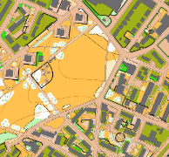
South Yorkshire Orienteers
Sheffield City Race
YHOA Urban League Event
Saturday 2ND July 2022
13.00- 15.00

Join us for a classic urban orienteering race in the challenging terrain of the Ponderosa and Kelham Island.

Final details

Travel & Parking

By Tram: The nearest Tram stop is Infirmary Road (Yellow and Blue Route), Park and ride options are available at Middlewood (S6 1TQ), Meadowhall (S9 1EP) and Nunnery Square (S2 5DH).
By car: There are many routes to the area, and lots of one-way streets in the immediate vicinity. Parking is on the street parking around the Ponderosa, obey traffic signs and be courteous to residents or Nearby Tesco Superstore has plenty of parking which is free for 3 hrs please purchase something if you do use this. Access from Montgomery Terrace Road or Albert Terrace Road. Postcode: S6 3BU.
Assembly
Assembly including registration, enquiries, download, are situated on the Ponderosa close to Upperthorpe Rd, S6 3DP, what three words maple.famed.lots.
A tent will be available to store kit.

Toilets Are available at Tesco Supermarket, Montgomery Terrace S6 3BU

Starts: 13.00 – 15.00 Courses close @ 16.30
It’s a punching start so don’t panic if you miss your start time.
There are two starts:
Ponderosa for Courses 5 & 6 (light green/novice and yellow)
Kelham Island start Approx 500m (10-to-15-minute walk) from assembly this is crossing a busy dual carriage way so take care. Please follow the tapes to the start. The area by the Kelham Island start has a small area to wait prior to your call up, please try not to arrive to early to avoid to many people congregating. We will be operating a 4 minute call up prior to your allotted start time, it will however be a punching start so if you arrive late you will be allowed to start in the next available slot. 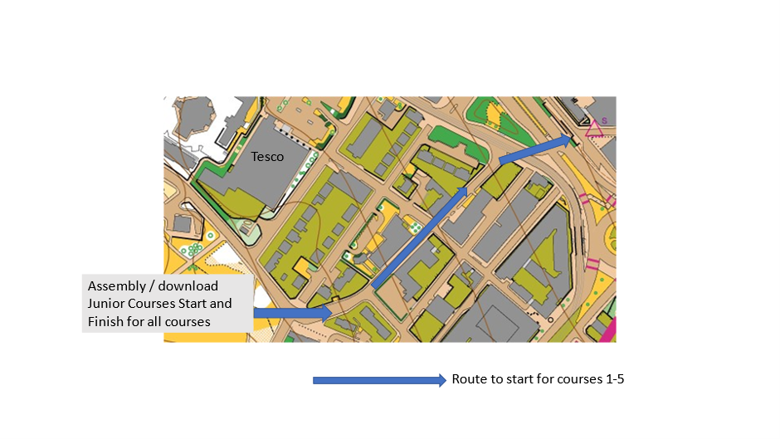
Control descriptions

Loose control descriptions are available for all courses these are pictorial which are printed on the map also.

Courses 6 and 7 has written control descriptions on the map but pictorial on the loose descriptions. If you are unfamiliar with pictorial control descriptions follow this link https://www.maprunner.co.uk/iof-control-descriptions/
ROAD CROSSINGS:
Please note all adult courses (1-5) are subject to using a 3-minute timed out MANDATORY road crossing via 2 pedestrian crossings over a very busy dual carriageway. THIS MUST BE OBSERVED. The return legs towards the final controls are via an underpass this is the only route to be used and no-one is allowed to cross over the dual carriageway by any other means. This is for your own safety so please observe this.
The Light Green crosses one road which is busier than the other ones encountered this will be marshalled to ensure the safety of those U16’s eligible to run this course.

Courses
This is part of the YHOA urban League to score in the league please select the appropriate course, Juniors who have not yet reached their 16th birthday on 2nd July can only run courses 6 and 7. Course 6 is only appropriate for M/W 14 and above due to road crossings.

Course | Course Length (Straight line, expect running distance about 40% longer) | YHOA Classes
1 Black | 7.2 km, 230m climb, 27 controls | Men Open (M18-M35)
2 Brown | 6.6 km, 210m climb, 25 controls | Women Open (W18-W35)  Men Veteran (M40+)
3 Blue | 5.1 km, 145m climb, 20 controls | Women Veteran (W40+)  Men Super Veteran (M55+)
4 Green | 3.9 km, 135m climb, 19 controls | Women Super Veteran (W55+)  Men Ultra Veteran (M65+)
5 Short Green | 3.3 km, 110m climb, 14 controls | Women Ultra Veteran (W65+)  Men Hyper Veteran (M75+)  Women Hyper Veteran (W75+)
6 Light Green | 3.1 km, 120m climb, 16 controls | Men Junior (M16-)  Women Junior (W16-)  Adult Novices
7 Yellow | 1.6 km, 85m climb, 12 controls | Men Young Junior (M12-)  Women Young Junior (W12-)

Terrain
The terrain is predominantly urban (no brambles!) with a few areas of park, open ground and small patches of woodland. Full leg cover is not required, though be aware there may be some summer undergrowth around some of the controls in the open areas.
Finish: By assembly.

Map Scale : 1:4000 5m contours
The map was updated March 2022 by Tim Tett and June 2022 by Steve Dempsey, the mapping spec is ISSOM 2007 (not ISSprOM 2019).
There is no key on the map

Courses 1 – 2 are double-sided A3 maps, with a generous overlap.
Courses 3,4 and 5 are single-sided A3 maps.
Courses 5 – 6 are single-sided A4 maps.

Mapping Notes
Below are some mapping features explained that will be present on some of the courses.
Please familiarise yourself with them to aid you safely around the course.
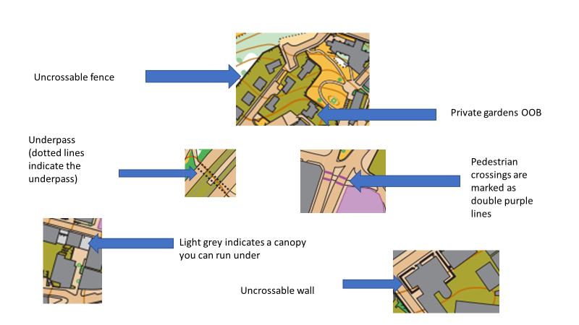

TIMED OUT ROAD CROSSING
As mentioned already Courses 1 -5 all cross a dual carriage using a 3 minute mandatory timed out crossing point. There are two sets of pedestrian crossings to negotiate, the timings to cross have been checked and 3 minutes is generous to allow you to cross safely (and catch your breath). This is for your own safety, the event is on Saturday afternoon so there will be plenty of traffic.
Returning to the Ponderosa requires you to use an underpass once again this is for your safety, and it is quicker than trying to get across the dual carriageway.
Entries
Entries open from 6th June on Fabian4 with self-selected start times.
Normal entries close on Sunday 26th to guarantee a map with late entries subject to map availability. EOD is subject to map availability.
£8 senior BOF members, (+£2 non-members) for MO, WO, MV, WV, MSV WSV, MHV, WHV.
£4 Juniors/Students MJ, WJ, MYJ, WYJ / all adult courses for students
We welcome helpers from any club. Please enter on Fabian4 using SYOHELPER to receive a 50% discount.

First Aid: will be provided at assembly.
A&E for adults: Northern General Hospital S5 7AU
A&E for children: Sheffield Children’s Hospital S10 2TH

Officials
Organiser: Susan Guy (sjmaguire@hotmail.com)
Planner: Colin Lynch
Controller: Clive Wilson

