
Regional Night Event at Loxley Common
In conjunction with the YHOA Night League

Saturday 2nd November 2019

Assembly Wadsley Jack Pub 66 Rural Lane S6 4BJ. The rear room is the location for registration and download, toilets are available here. The bar will be open and there is a full food menu on offer from 5pm to 8pm.
Please only use the pub car park if you are intending to stay for food and drink after the event. Otherwise there is plenty of parking on the surrounding residential streets or at the Loxley Common Car Park (S6 4BZ). There is a
5-minute walk to the start from assembly this is taped. There will be an unmanned tent available in the Loxley Common Carpark near the start and finish for a clothes/bag drop.

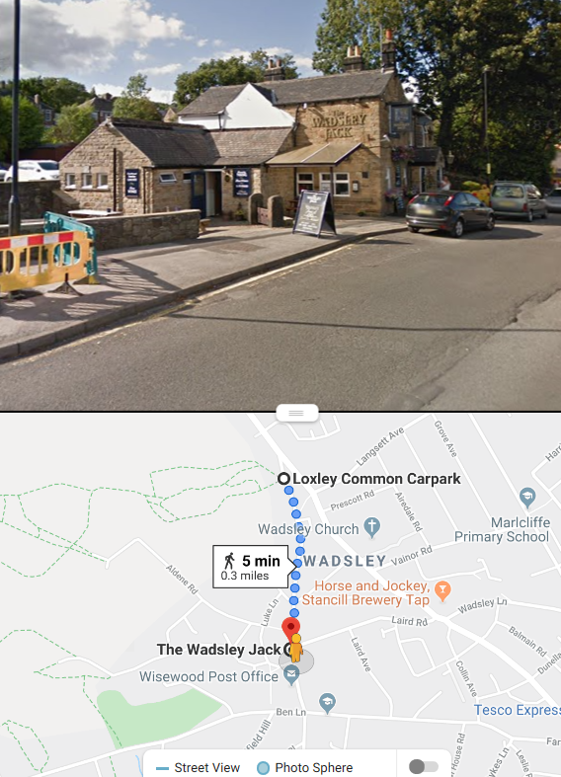

Times: Registration: 17.00 - 18.15
Starts: 17.15 – 18.45
Course close: 20.15

If you think you are going to be out for a long time please start earlier.

Fees: EOD only
 | Fee
Senior | £10.00 (£8 BOF members)
Junior/Student | £4.00
Beginner Course | £4.00
Family | £24.00 (£20 BOF members)

Pairs are welcome – just pay for 1 entry.

SI card hire: £1 Lost SI card fee: £30

Helpers can get a 50% discount.

Courses:
Course | Length | Climb | Controls | Technical Difficulty
Beginner | 2km | 70m | 11 | Easy (Yellow)
Short | 2.8km | 85m | 15 | Medium (Orange)
Medium | 3.2km | 125m | 15 | Difficult
Long | 4.1km | 160m | 18 | Difficult

Juniors are very welcome but those who are not confident on all types of orange course in the daylight should be accompanied by an adult.

Terrain: Loxley Common comprises of large areas of open common land interspersed with areas of woodland. There is a complex network of paths, interesting vegetation detail and some areas of intricate contour detail created by old mine / quarry workings. The southern wooded slopes are very rocky. There are some areas of bramble but planning avoids the worst of this.

Map: Map scale is 1:5000, updated October 2019 by Dave Peel to ISOM 2017-2
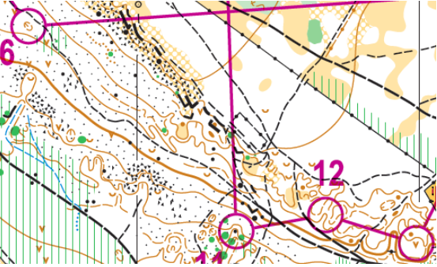

Safety: Competitors take part at their own risk & are responsible for their own safety.
HEADTORCHES, WHISTLES AND FULL LEG COVER ARE COMPULSORY. Cagoules may be compulsory if the weather conditions are poor.
ALL COMPETITORS MUST REPORT TO DOWNLOAD EVEN IF THEY RETIRE.

YHOA Night League Information
The classes are:
Junior Men/Women (M/W 16-)
Senior Men/Women (M/W 18/20/21/35)
Veteran Men/Women (M/W 40/45/50)
Super Vet Men/Women (M/W 55+)
Ultra Vet Men/Women (M/W 65+)

Each age group category can enter any course to score league points; except Junior Women, Veteran Women and Super Veteran Women and Ultra Veteran Men who enter the Long course will not score league point for their age group.

Officials: Planner: Beverley Inkson and Seb Mobus (SYO)
Controller: Lucy Wiegand (SYO)
Organiser: Susan Guy (SYO)
- Email: sjmaguire@hotmail.com
- Mobile: 07734866202

We would like to thank the Wadsley Jack for allowing us to use their room for this event.

