South Yorkshire Orienteers
Hugset middle distance race March 19th 2017
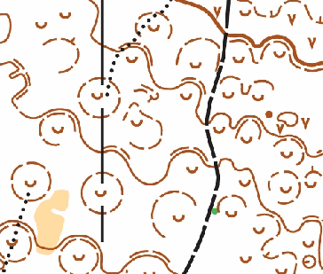
2012 map
A full set of colour coded courses will be on offer, please enter by age class (no Short courses) for the YHOA middle distance championships. It is a level B event and also a counter in the YHOA Superleague.
Entries now open on Fabian4 in conjunction with the Sheffield outdoor weekender urban event running from Norfolk Park.
Hugset should be approached from the M1, take exit 37, head West, right at the first roundabout left at the second, onto the A628, right at the 3rd roundabout towards Higham, after 1.3km take a sharp left, signed in front of the pub, Pogwell lane. Parking will be in a small paddock with overflow onto roadside. £1 per car, please share as it will be tight. Registration adjacent to car park, start and finish within 5 minutes walk.
A small wood but packed with bell pits and other interesting contour detail. Split between deciduous smaller trees with lovely spring flowers and coniferous plantation that is very mature and can offer ground vegetation free running. Newly re mapped by Peter Gorvett 1:5000 with 2.5m contours.
Registration for courses will open from 1000-1230. You can start from 1100-1300 please try to use your allocated start block, the courses close at 1430. The British University Championships relays are taking place earlier in the morning, but the leaders should be clear of the forest by 11:00.
Entries
All courses will allow entry on the day, though we suggest that those wanting to run enter in advance to ensure they get a map.
Costs
Level B courses adults on Light Green and above: £13 (£11 members). A surcharge of £2 will be added after the first closing date 05/03/2017 and for entries on the day. Online entries will stay open until Midnight on Friday 17th, but there may not be full map/course availability after the first closing date.
Juniors £5, no late / eod surcharge
Families of 2 adults and up to 4 children running separate courses £27
Shorter courses (white to orange): Adults, family groups, juniors £5
Any additional courses/ maps will cost an additional £3 on the day
SI hire £1, lost SI dibbers £30
Officials
Planner Roger Lewis (SYO)
Organiser Lucy Wiegand (SYO) lucywiegand@googlemail.com 01142680541
Controller Steve Whitehead (EBOR)

